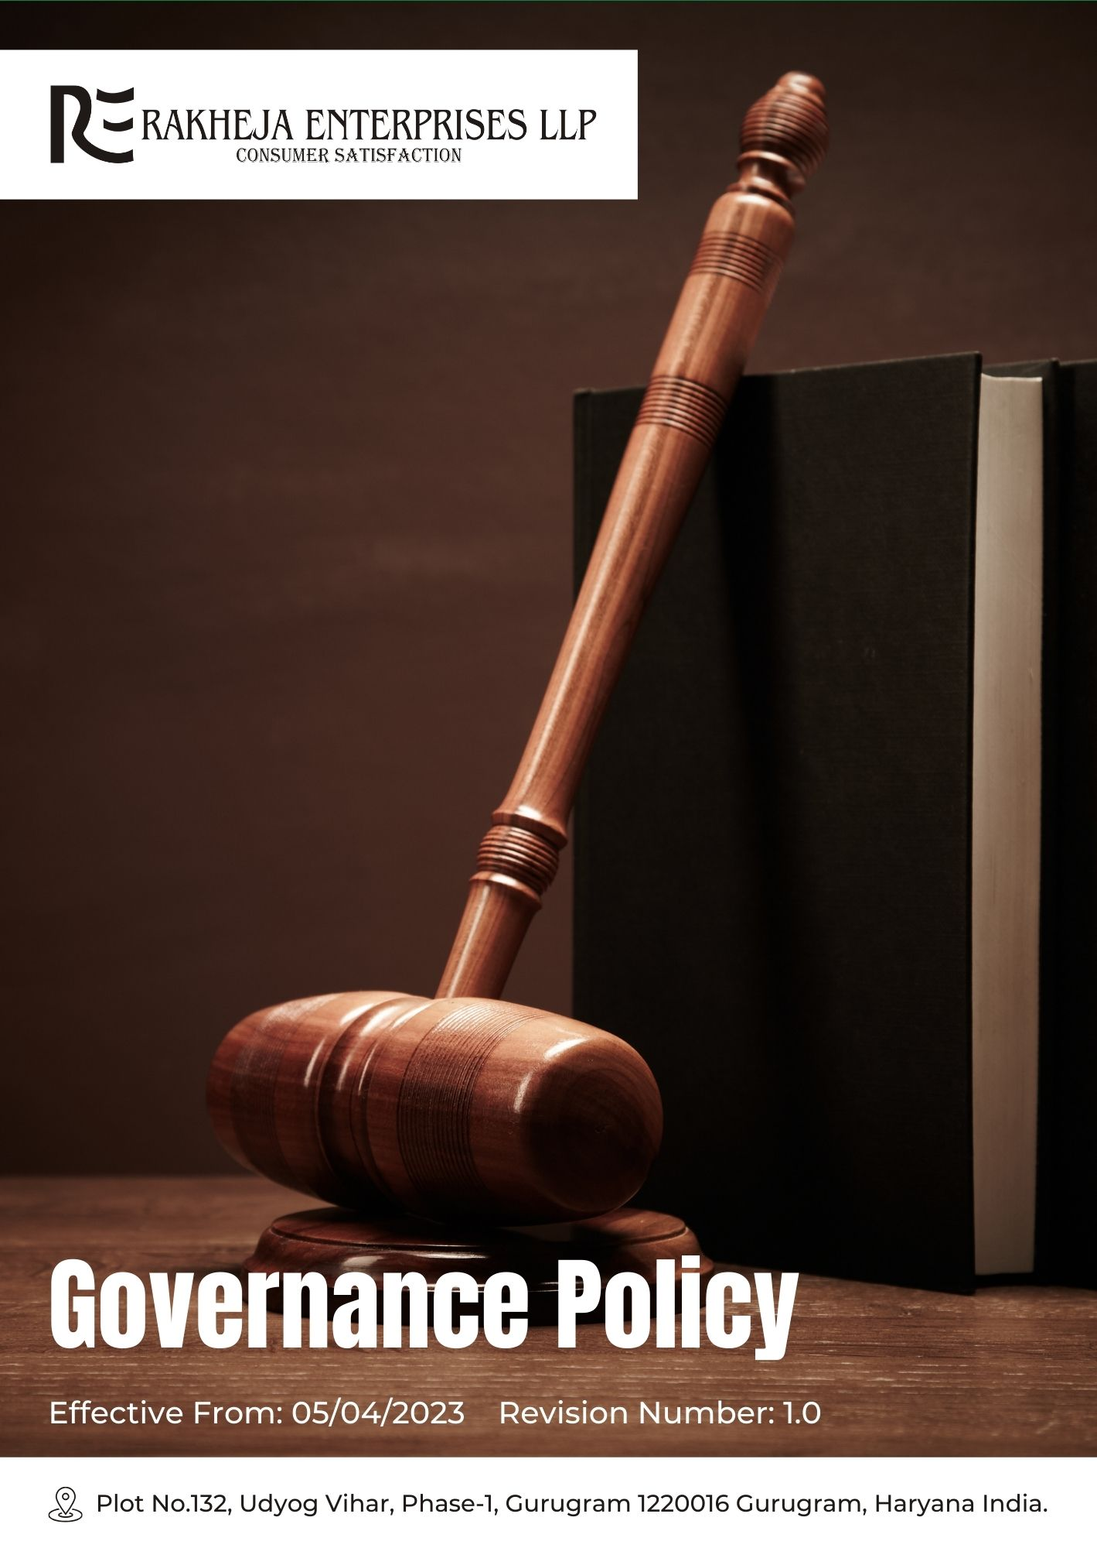
Table of Contents
1. Introduction 3
2. Planned objectives 3
3. Scope 3
4. Rakheja’s Governance key strategies and targets 4
5. Responsibility 6
6. Reporting 7
7. Consequences for Violation of this Policy 8
8. Continuous Improvement 10
9. Review Cycle 11
10. Acknowledgement by Employee 12

Introduction
At Rakheja Enterprises LLP, we are committed to maintaining the highest standards of corporate governance. We ensure transparency, accountability, and integrity in all our operations and decision-making processes. Our governance policy emphasizes ethical behaviour, compliance with laws and regulations, and effective stakeholder engagement to foster trust and sustainability. We prioritize open communication channels and continuous improvement to uphold our commitment to good governance practices.

Planned objectives
- Ethical Conduct: Ensure all business activities are conducted ethically and in compliance with applicable laws and regulations.
- Transparency: Maintain transparency in our operations, financial reporting, and decision-making processes.
- Accountability: Hold all levels of the organization accountable for their actions and decisions.
- Stakeholder Engagement: Foster active engagement with stakeholders to understand their concerns and expectations.
- Risk Management: Identify, assess, and manage risks effectively to safeguard the company’s assets and reputation.
- Compliance: Ensure compliance with corporate governance principles and standards set by regulatory bodies.

Scope
This Policy applies to all employees (at all levels), all stakeholders, partners, contractors, customers, suppliers, and any other individual or entity working on behalf of Rakheja Enterprises LLP. It also applies to all our manufacturing facilities.

Rakheja’s Governance key strategies and targets
- Corruption:
- We have implemented the Compliance Management System (CMS) with robust monitoring and auditing processes, achieving a 100% reduction in corruption incidents by FY 2025-26, compared to FY 2022-23.
- We look to our Anti-Corruption Compliance Team and regular risk assessments using Ethical Risk Assessment Tools to ensure 100% detection of potential issues by FY 2025-26.
- We have conducted mandatory annual training sessions using Scenario-Based Training Platforms, focusing on real-world scenarios and ethical decision-making, aiming for 100% employee participation by FY 2025-26.
- Conflict of Interest:
- We have utilized the Conflict-of-Interest Management System (CIMS) with a robust reporting system to ensure a 100% increase in adherence to conflict-of-interest management by FY 2025-26, compared to FY 2022-23.
- We look to our Online Conflict Reporting Portal and Ethics Committee to review 100% of disclosures and provide guidance by FY 2025-26.
- We have conducted quarterly compliance reviews using the Compliance Review Tracker and updated processes annually based on best practices and employee feedback, achieving 100% compliance by FY 2025-26.
- Money Laundering:
- We have enhanced AML controls with Real-Time Transaction Monitoring Systems and rigorous due diligence procedures to achieve a 100% reduction in money laundering incidents by FY 2025-26, compared to FY 2022-23.
- We look to our Bi-Annual AML Audits conducted by an external firm to ensure 100% compliance with regulations by FY 2025-26.
- We have introduced the Whistleblower Hotline System to ensure 100% accessibility for anonymous reporting of suspicious activities by FY 2025-26.
- Data Manipulation:
- We have established robust data integrity systems with Advanced Encryption Technologies and Regular Data Audits to achieve a 100% reduction in data manipulation incidents by FY 2025-26, compared to FY 2022-23.
- We look to our Quarterly Data Integrity Reviews involving cross-departmental teams and Sophisticated Monitoring Tools to ensure 100% compliance by FY 2025-26.
- We have addressed data discrepancies promptly with Comprehensive Review Processes and Automated Issue Resolution Systems, targeting 100% issue resolution by FY 2025-26.
- Anti-Competitive Practices:
- We have implemented a comprehensive compliance framework with Market Behaviour Monitoring Systems and Employee Training Platforms to achieve a 100% reduction in anti-competitive practices by FY 2025-26, compared to FY 2022-23.
- We look to our Compliance Monitoring Unit to oversee 100% of market practices and provide real-time guidance by FY 2025-26.
- We have ensured 100% employee participation in training on fair competition laws using Interactive Training Modules by FY 2025-26.
- Fraud:
- We have deployed Advanced Fraud Detection Systems like Predictive Analytics Software and Anomaly Detection Technologies to achieve a 100% reduction in fraud incidents by FY 2025-26, compared to FY 2022-23.
- We look to our Quarterly Fraud Risk Assessments using Sophisticated Analytical Tools to achieve 100% identification of potential vulnerabilities by FY 2025-26.
- We have established a Fraud Prevention Task Force to review 100% of incidents and refine detection strategies using Fraud Analysis Platforms by FY 2025-26.
- Information Security Management:
- We have enhanced information security with Multi-Factor Authentication Systems and Intrusion Detection Systems to achieve a 100% reduction in security breaches by FY 2025-26, compared to FY 2022-23.
- We look to our Annual Information Security Training Programs including Practical Incident Response Simulations to achieve 100% employee participation by FY 2025-26.
- We have performed regular security audits and penetration tests using Advanced Security Testing Tools to ensure 100% effectiveness in strengthening defences by FY 2025-26.

Responsibility
- Senior Management
- Ensure the implementation and effectiveness of governance strategies aligned with the company’s mission and values.
- Allocate necessary resources to support effective governance practices.
- Engage with external stakeholders to stay informed on best practices and compliance requirements.
- Oversee risk management related to governance issues and ensure adequate measures are in place.
- Governance Committee
- Develop and deliver training programs related to governance and compliance.
- Monitor compliance with governance policies and internal controls.
- Conduct regular reviews and updates of the governance policy to ensure relevance and effectiveness.
- Compliance Officer
- Review and approve updates to the governance policy based on performance metrics and evolving regulations.
- Conduct regular audits to ensure compliance with governance policies and procedures.
- Investigate any reported violations or concerns related to governance practices.
- Develop and maintain reporting mechanisms for governance issues and ensure transparency in disclosures.
- Facilities Management
- Implement and maintain safety measures to protect employees' health and prevent injuries.
- Conduct regular emergency drills and simulations to ensure readiness and safety across all departments.
- Oversee the maintenance of a secure and conducive work environment.
- Employees
- Follow the company's governance policies and practices, including ethical behavior and compliance.
- Report any observed violations of governance policies through established channels.
- Engage in and complete mandatory training programs related to governance and compliance.

Reporting
Transparent and regular reporting is crucial for monitoring the effectiveness of our governance framework, ensuring accountability, and driving continuous improvement. Rakheja Enterprises LLP implements the following reporting procedures:
- Regular Governance Performance Reports: We conduct annual evaluations of our governance practices, gathering data on key metrics outlined in our Governance Strategy. These reports include an assessment of compliance with governance standards and progress towards our policy objectives.
- Internal Audits: We perform internal audits to evaluate adherence to governance policies and procedures, assess the effectiveness of our governance management systems, and identify areas requiring corrective action. These audits help ensure ongoing compliance and facilitate continuous improvement.
- Stakeholder Engagement: We actively engage with stakeholders, including employees, board members, investors, and regulators, to solicit feedback, address concerns, and communicate our governance practices and performance. This engagement ensures transparency and fosters a collaborative approach to governance issues.
- Grievance Reporting Mechanisms: We provide accessible channels for employees and stakeholders to report governance-related violations or concerns. Reports are reviewed promptly, and actions are taken to resolve issues and prevent recurrence. This mechanism supports our commitment to accountability and continuous improvement.
- Public Disclosures: We enhance transparency by publicly disclosing our governance performance, including progress towards policy objectives and responses to stakeholder concerns. These disclosures are made through our website, annual reports, and other communication channels, ensuring that our commitments are visible and accessible.
- Policy Review and Updates: We regularly review and update our governance policy based on performance reports, audit findings, and stakeholder feedback. This ensures that the policy remains relevant, effective, and aligned with best practices and evolving governance standards.

Consequences for Violation of this Policy
At Rakheja Enterprises LLP, we take violations of our governance policy very seriously. All employees and stakeholders are expected to adhere strictly to the principles outlined in this policy. Failure to comply with the governance policy will result in appropriate disciplinary actions and measures to address the breach. The consequences for violations may include:
- Disciplinary Actions:
- For Employees: Violations of the governance policy by employees may result in disciplinary actions ranging from formal warnings to suspension or termination of employment, depending on the severity and nature of the breach. Repeat offenses or serious violations will be treated with increased severity.
- For Management and Senior Executives: Serious breaches involving management or senior executives may lead to removal from their positions, legal action, and termination of employment. The company will conduct thorough investigations to determine the appropriate course of action.
- Legal Consequences:
- For Illegal Activities: Any violations involving illegal activities such as fraud, corruption, or money laundering will be reported to the relevant authorities. Legal proceedings may be initiated, and individuals involved may face criminal charges, fines, and imprisonment as applicable under the law.
- Financial Penalties:
- For Contractors and Suppliers: Contractors and suppliers who violate the governance policy may face financial penalties, including termination of contracts, loss of business, and legal action to recover damages. We will ensure that contractual agreements include provisions for compliance and penalties for breaches.
- Corrective Measures:
- For All Parties: In addition to disciplinary actions, we will implement corrective measures to address the root cause of the violation. This may include additional training, process improvements, and revisions to policies and procedures to prevent future occurrences.
- Reputational Damage:
- For the Company and Individuals: Violations of the governance policy may lead to reputational damage for the company and individuals involved. We will take steps to mitigate any negative impact and restore trust through transparent communication and corrective actions.
- Review and Appeal:
- For Employees and Stakeholders: Individuals subject to disciplinary actions have the right to appeal decisions through established grievance mechanisms. We will review appeals fairly and impartially, ensuring that all parties have an opportunity to present their case.

Continuous Improvement
At Rakheja Enterprises LLP, we are committed to continuous improvement in our governance practices. We actively seek feedback from stakeholders, including employees, partners, and regulatory bodies, to identify areas for enhancement. Our approach includes regular performance assessments and benchmarking against industry standards to ensure we meet and exceed best practices. We prioritize the integration of lessons learned from internal audits, risk assessments, and external reviews into our governance framework. By fostering a culture of open communication and accountability, we encourage proactive identification and resolution of governance issues. Our commitment to continuous improvement drives us to refine our policies, update training programs, and adopt innovative solutions to enhance transparency, accountability, and ethical conduct across all levels of the organization.

Review Cycle
Rakheja Enterprises LLP will conduct a biennial review of our governance policy to ensure its continued relevance and effectiveness. This review, overseen by the Compliance Officer, will include an assessment of compliance with governance standards, evaluation of performance reports, and examination of audit findings. Stakeholder feedback will be incorporated to address any emerging issues or areas for improvement. The Compliance Officer will lead the review process, ensuring that the policy remains aligned with best practices and evolving governance requirements. Updates will be made as necessary to enhance policy effectiveness and address any identified gaps.
Prepared By (Name) | Compliance Officer
Date of Preparation | 27/03/2023
Prepared by (Signature)
Approved By | General Manager
Date of Approval | 31/03/2023
Signature of Approver
Implementation Date | 05/04/2023
Next Review Date | 01/04/2025

Acknowledgement by Employee

I, acknowledge that I have received, read, and understood the Governance Policy of Rakheja Enterprises LLP. I understand that this policy outlines the company's commitment to maintaining high standards of corporate governance, including ethical conduct, transparency, accountability, and effective stakeholder engagement.
I am aware that adherence to this policy is mandatory and that it applies to all employees, stakeholders, partners, contractors, customers, and suppliers associated with Rakheja Enterprises LLP. I acknowledge my responsibility to comply with the guidelines and procedures set forth in the policy and to report any violations or concerns through the established channels.
I understand that failure to adhere to this policy may result in disciplinary action, up to and including termination of employment. I also recognize that the policy will be periodically reviewed and updated, and it is my responsibility to stay informed of any changes.
By signing this acknowledgment, I confirm my commitment to upholding the principles outlined in the Governance Policy and to contributing to the company's dedication to transparency and ethical conduct.
Employee Name
Acknowledgement Date
Signature

